Internship Report
On
“AI Student Performance Prediction System”
Submitted To
School of Computer Science and Engineering
IILM University, Greater Noida, U.P.
In partial fulfilment of the requirement of degree of
B.Tech CSE

By
Roll Number of Student: 2410030269
Name of Student: SHUBHRAJ
Batch: 2024-2028

CANDIDATE'S DECLARATION
I, SHUBHRAJ, do hereby declare that the internship report titled “AI Student Performance Prediction System” has been completed by me to fulfil the requirement for the award of the degree of Bachelor of Technology in CSE. All the references have been quoted and I have not taken as such any material from any other source. I affirm to you that this report is my own and has not been submitted to any other institute for any degree/diploma requirement and further I shall be solely responsible for any kind of copyright violation in this regard.
Signature
Student Name: SHUBHRAJ
Roll No.: 2410030269

ACKNOWLEDGEMENT
I am using this opportunity to express my gratitude to everyone who supported me throughout the Internship Program at Central Coalfields Limited (CCL), System Department, Hazaribagh Area. I am thankful for their aspiring guidance, invaluably constructive criticism and friendly advice during this work. I am sincerely grateful to Mr. Suraj Kumar, SO (System) In-Charge at Hazaribagh Area, CCL, for his mentorship and for sharing his truthful and illuminating views on a number of issues related to this work.
I also extend my gratitude to the faculty of the School of Computer Science and Engineering, IILM University, Greater Noida, for their continuous support and guidance throughout the internship.
I express my gratitude to my parents for their blessings.
Signature
Student Name: SHUBHRAJ
Roll No.: 2410030269

INTERNSHIP COMPLETION CERTIFICATE
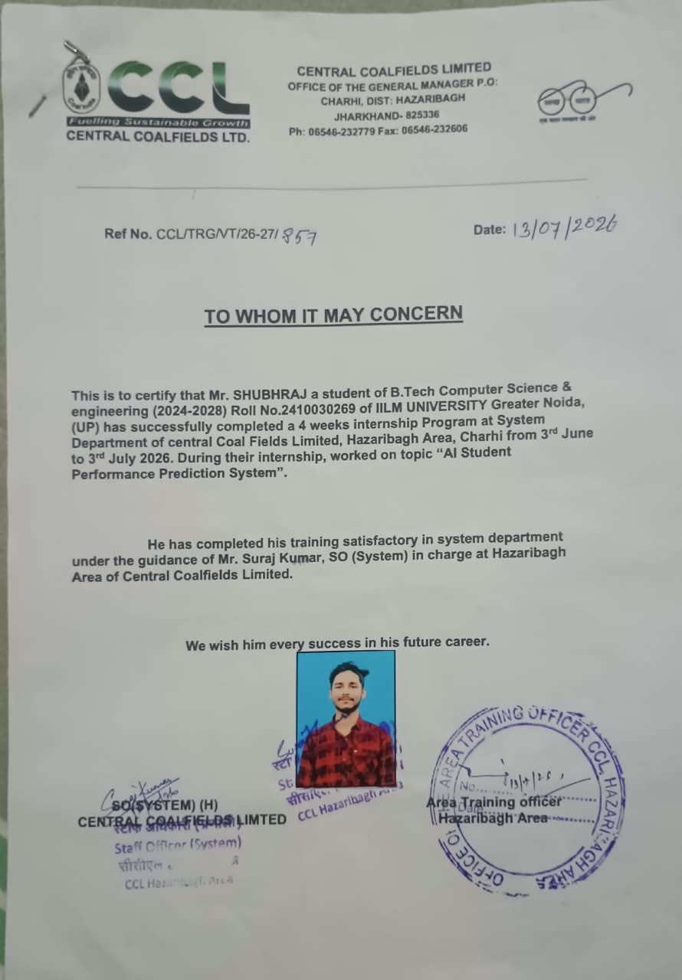
Figure 3.1: Certificate issued by Central Coalfields Limited (To Whom It May Concern)

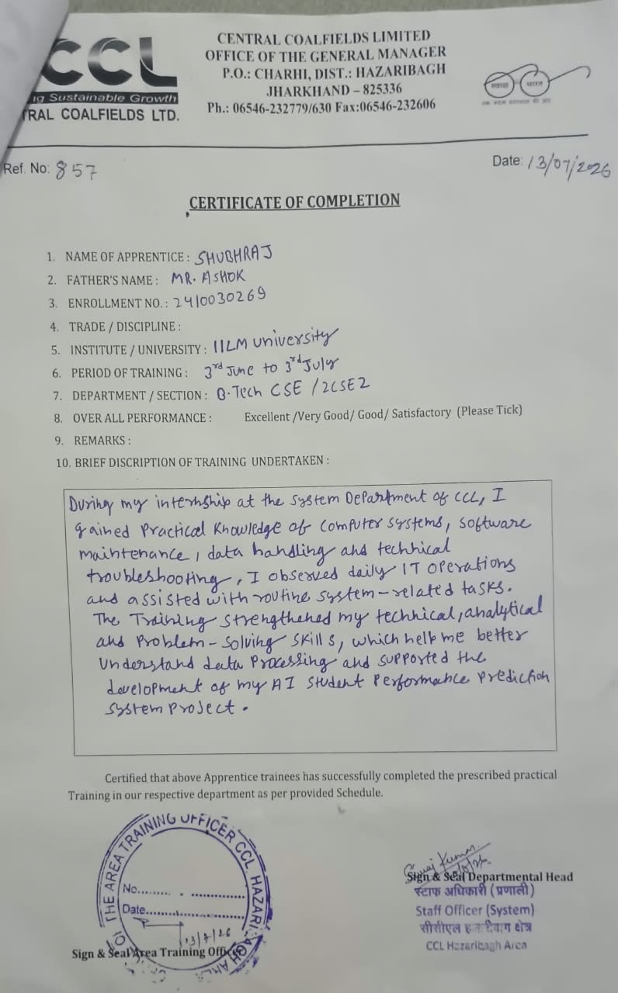
Figure 3.2: Certificate of Completion – CCL Training Undertaken

LIST OF TABLES
Table 4.1 Technologies and Tools Used 2

LIST OF FIGURES
Figure 3.1 Certificate issued by Central Coalfields Limited iii
Figure 3.2 Certificate of Completion – CCL Training Undertaken iv
Figure 4.1 System Architecture of the AI Student Performance Prediction System 3
Figure 4.2 Office Order – VT Allotment Letter, Central Coalfields Limited 5

TABLE OF CONTENTS
Chapter No. | Chapter Name | Page Nos.
 | Cover Page | ---
1. | Candidate's Declaration | i
2. | Acknowledgment | ii
3. | Internship Completion Certificate | iii – iv
4. | Project Description  4.1 Introduction  4.2 Organization Profile  4.3 Problem Statement  4.4 Project Objectives  4.5 Scope of the Project  4.6 Technologies and Tools Used  4.7 System Architecture  4.8 Methodology  4.9 Expected Outcomes  4.10 Certificates of completion and other communication mail proof | 1  1  1  1–2  2  2  2  3  3  3  4
5. | Bibliography/References | 6

4. Project Description

4.1 Introduction
This report presents an account of the four-week industrial internship undertaken at Central Coalfields Limited (CCL), a Miniratna subsidiary of Coal India Limited, at the System Department, Hazaribagh Area, Charhi, Jharkhand, from 3rd June 2026 to 3rd July 2026. The internship was carried out under the guidance of Mr. Suraj Kumar, SO (System) In-Charge, Hazaribagh Area, as part of the requirement for the degree of Bachelor of Technology in Computer Science and Engineering at IILM University, Greater Noida.
During the internship, exposure was gained to the day-to-day functioning of the System Department, including system maintenance, software handling, data management and routine IT operations and troubleshooting. Alongside this practical exposure, the internship project titled “AI Student Performance Prediction System” was undertaken, aimed at applying data-driven and machine learning techniques to predict and analyse student academic performance.

4.2 Organization Profile
Central Coalfields Limited (CCL) is one of the leading subsidiaries of Coal India Limited (CIL), a Maharatna public sector undertaking under the Ministry of Coal, Government of India. Headquartered in Ranchi, Jharkhand, CCL is primarily engaged in the exploration, extraction and production of coal across its various coalfields and areas in the state of Jharkhand, including the Hazaribagh Area, where this internship was undertaken.
The System Department at CCL, Hazaribagh Area, is responsible for the upkeep of computer systems, software infrastructure, data handling and IT-enabled operations that support the organization's administrative and operational functions. The department plays a key role in ensuring smooth day-to-day IT operations, technical troubleshooting and systems support across the area office.

4.3 Problem Statement
Educational institutions and training organizations often rely on manual or ad-hoc methods to assess and track student/trainee academic performance, which makes it difficult to identify at-risk individuals early or to draw meaningful insights from historical performance data. There is a need for a systematic, data-driven approach that can analyse existing academic and behavioural data to predict future performance and support timely, informed intervention.

4.4 Project Objectives
- To study and understand the factors that influence student academic performance.
- To collect and preprocess relevant academic data for analysis.
- To design and implement a machine learning model capable of predicting student performance.
- To evaluate the performance of the developed model using standard evaluation metrics.
- To present the predictions through a simple, interpretable dashboard/output for end users.

4.5 Scope of the Project
The scope of the project is limited to building a prototype prediction system that takes available academic and related attributes as input and outputs a predicted performance category or score. The project focuses on the core data pipeline, model development and evaluation, and does not extend to full-scale deployment, integration with institutional databases, or handling of real-time streaming data, all of which are identified as areas for future enhancement.

4.6 Technologies and Tools Used
The project was developed using standard open-source tools commonly used for data analysis and machine learning tasks, as summarized in Table 4.1 below.
Technology / Tool | Purpose
Python | Core programming language for data processing and model development
Pandas / NumPy | Data handling, cleaning and numerical computation
Scikit-learn | Building and evaluating machine learning models
Matplotlib / Seaborn | Data visualization and result analysis
Jupyter Notebook | Interactive development and experimentation
Table 4.1: Technologies and Tools Used
Note: The specific tools listed above are indicative of a typical Python-based machine learning workflow. Please update this list with the exact libraries/tools actually used in your implementation, if different.

4.7 System Architecture
The system follows a linear data pipeline architecture consisting of five stages: data collection, data preprocessing, feature engineering, model training and evaluation, and finally prediction and presentation of results, as illustrated in Figure 4.1.
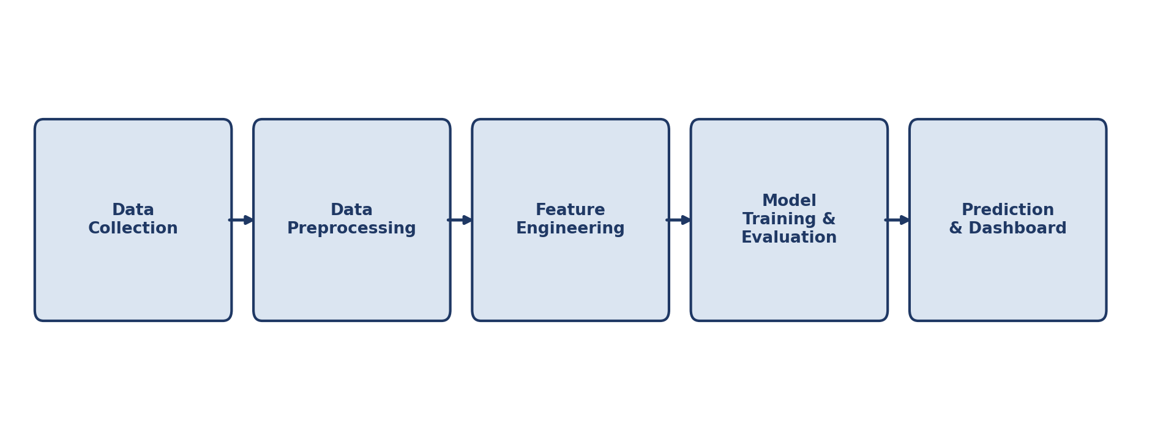
Figure 4.1: System Architecture of the AI Student Performance Prediction System

4.8 Methodology
- Data Collection: Relevant student academic and demographic data were gathered/simulated for the study.
- Data Preprocessing: The collected data was cleaned to handle missing values, inconsistencies and outliers.
- Feature Engineering: Relevant features affecting student performance were identified and encoded for model consumption.
- Model Selection and Training: Suitable machine learning algorithms (e.g., regression/classification models) were selected and trained on the processed dataset.
- Evaluation: The trained model was evaluated using appropriate metrics such as accuracy, precision/recall, or RMSE, depending on the problem formulation.
- Deployment/Presentation: The final predictions were presented through a simple, interpretable output for end users.

4.9 Expected Outcomes
- A working prototype capable of predicting student performance based on input academic data.
- Early identification of students who may need additional academic support.
- Improved understanding of the key factors influencing student performance.
- A foundation for future development into a fully deployable, institution-wide prediction system.

4.10 Certificates of Completion and Communication Proof
The certificate of completion issued by Central Coalfields Limited (CCL), along with the detailed Certificate of Completion form describing the training undertaken, have been attached in Chapter 3 – Internship Completion Certificate (Figures 3.1 and 3.2) of this report.
In addition, the official communication proof – the Office Order issued by Central Coalfields Limited allotting the vocational training to the student in the System Department, AHQ, Hazaribagh Area – is attached below as Figure 4.2.

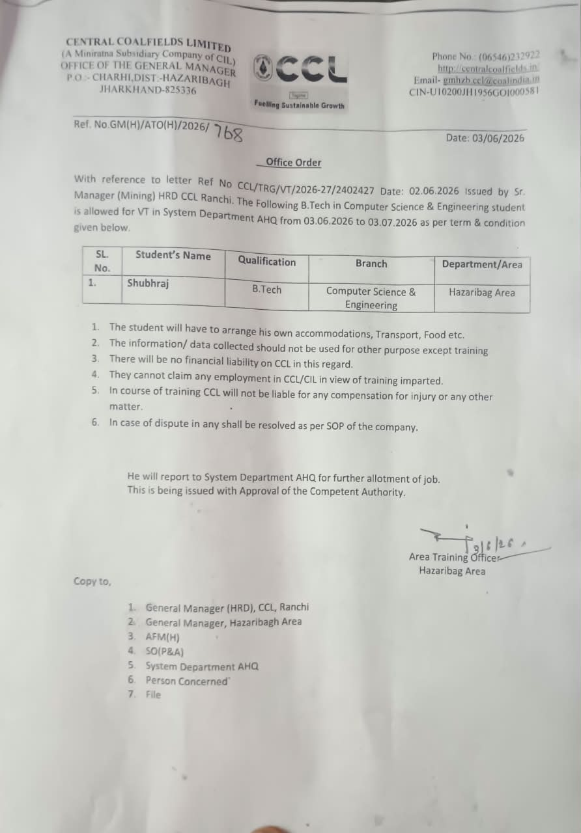
Figure 4.2: Office Order – VT Allotment Letter, Central Coalfields Limited

5. Bibliography / References
1. Central Coalfields Limited – Official Website. Available at: https://www.centralcoalfields.in
2. Coal India Limited – Official Website. Available at: https://www.coalindia.in
3. Pandas Documentation. Available at: https://pandas.pydata.org/docs/
4. Scikit-learn Documentation. Available at: https://scikit-learn.org/stable/documentation.html
5. Python Software Foundation. Python Documentation. Available at: https://docs.python.org/3/
Note: Please update the reference list above with the exact sources, textbooks, papers or websites you referred to while carrying out this project.

